# Bug Report

## cd-037

## Aryamman Jain, Pranav Mehndiratta, Vaibhav Vijay

Bug 1

|  |  |
| --- | --- |
| Bug Title | Usage of strtok() for parsing |
| Date Seen | March 12, 2014 |
| Environment | Ubuntu 13.10 x64 |
| Description | Strings parsed by strtok are modified, cannot be reused in other functions. |
| Severity* | Major |
| Steps to Reproduce | 1. Connect to server and authenticate. 2. Set a new key and value using the client shell. 3. Get the same key through client shell |
| Actual Behavior | Printed value is only the first column-value pair though record contains more than 1 column. |
| Expected Behavior | Complete value i.e. all column-value pairs are printed when accessed through a Get request. |
| Troubleshooting | 1. Check length of returned value and print that many characters. |
| Solution | Run strtok() on a copy of the input using strcpy(). |

Bug 2

|  |  |
| --- | --- |
| Bug Title | Setting of authenticated “boolean flag” back to false in “client_disconnect” |
| Date Seen | March 14, 2014 |
| Environment | Mac OSX |
| Description | Segment faults, as it required access to variables that required authentication. |
| Severity* | Trivial |
| Steps to Reproduce | 1. Connect to server and authenticate. 2. Setting a key with value 3. Disconnect from server 4. Getting stored key |
| Actual Behavior | Incorrect error code. Printed segment fault when disconnected. |
| Expected Behavior | After disconnecting, server shouldn’t allow get/set and print the correct error code. |
| Troubleshooting | 1. Printing error code and adding printing flags in client_disconnect(). |
| Solution | Change the ‘ authenticated’ boolean in client_disconnect() back to false. |

Bug 3 (Figure 1)

|  |  |
| --- | --- |
| Bug Title | Incorrect result for number of matched keys from query func |
| Date Seen | March 14, 2014 |
| Environment | SMP Debian 3.2.54 x86_64 |
| Description | Number of keys were being incremented on modification and addition of records |
| Severity* | Major |
| Steps to Reproduce | 1. Connect to server and authenticate. 2. Setting a key with value 3. Setting same key with new value (repeat many times) 4. Running query that should return this key |
| Actual Behavior | Same key is returned multiple times |
| Expected Behavior | Only one key should be returned (as keys are unique) |
| Troubleshooting | 1. Print all keys being compared to predicate |
| Solution | Problem traced back to server_set. Number of keys were being incremented during both addition/modification of records. |

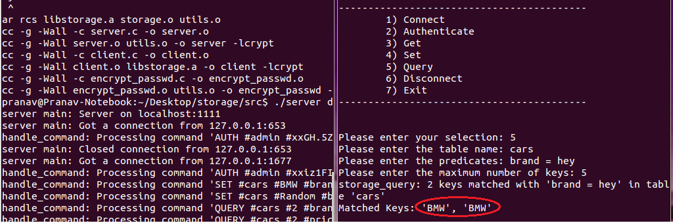

Figure 1: Captured while debugging